Evolution of the Major Programming Languages (Part 1)

Introduction

This chapter deals with the history of programming languages and how they evolved along with the computer systems on which they were implemented. The textbook adds a little bit of background in terms of the hardware development which paralleled the languages and I will try to add some more of this background in this set of notes. It is important to remember that the evolution of programming languages must be considered in the context of the hardware available at the time as the two are too closely linked to be considered in isolation. For reference, Figure 1 illustrates the genealogy of many popular high-level programming languages.

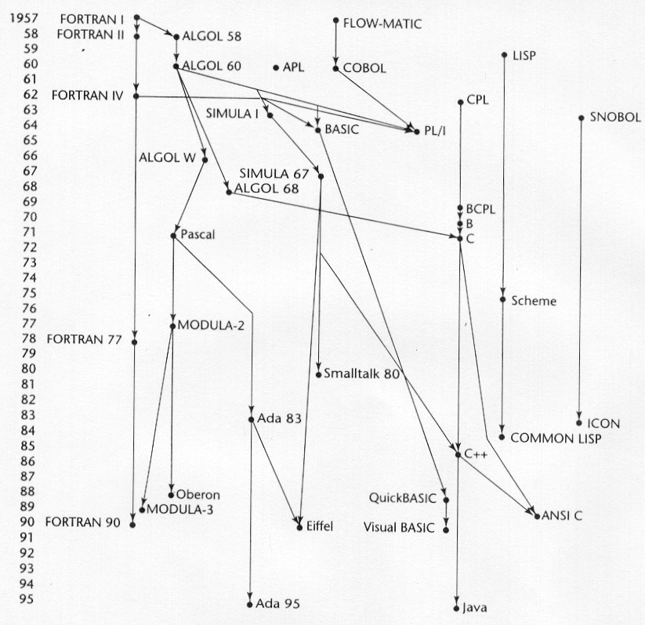

Figure 1 – Genealogy of some common programming languages.

Early High-Level Programming Languages

1945: Konrad Zuse’s Plankalkül

Many encyclopedias and other reference works state that the first large-scale automatic digital computer was the Harvard Mark 1, which was developed by Howard H. Aiken (and team) in America between 1939 and 1944. However, in the aftermath of World War II it was discovered that a program controlled computer called the Z3 had been completed in Germany in 1941, which means that the Z3 pre-dated the Harvard Mark I. German scientist Konrad Zuse (1910-1995) developed a series of electromechanical computers in period from 1936 to 1945 and developed his first machine, the Z1, in his parents' living room in Berlin in 1938.
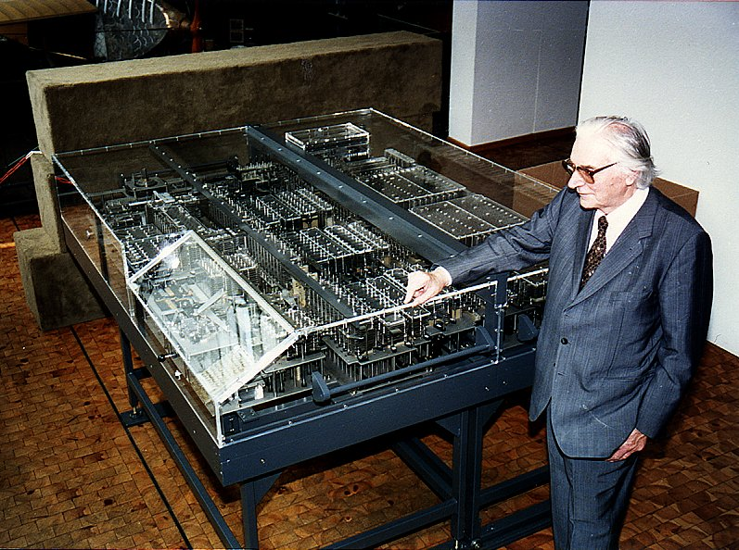
Konrad Zuse with the rebuilt Z1 in the Deutsche Technik Museum Berlin in 1989
Zuse was an amazing man who was years ahead of his time. To fully appreciate his achievements, it is necessary to understand that his background was in construction and civil engineering (not electronics). Also, Zuse was completely unaware of any computer-related developments in Germany or in other countries until a very late stage, so he independently conceived and implemented the principles of modern digital computers in isolation. The last model, named the Z4, was the only one of his original computers to survive the war. His research group disbanded after Zuse himself moved to the Bavarian village of Hinterstein in 1945 where he established his first company, Zuse KG. The first task of Zuse KG in 1949 was to restore the Z4, which survived the air attacks of the allies in Berlin and on the way from Berlin to Hinterstein.
Today it is undisputed that Konrad Zuse's Z3 was the first fully functional, program controlled (freely programmable) computer in the world. The Mark II, the ENIAC and the Colossus followed 1943 and later. The Z3 was presented on May 12, 1941 to an audience of scientists in Berlin. The demonstration was a success.
The Z3 as the Z1 contained practically all the features of modern day computers. The Z3 was built with relays. The Z3 did not have a jump instruction. Konrad Zuse, however, did know the jump instruction, as he implemented it in the micro code for floating point calculations.
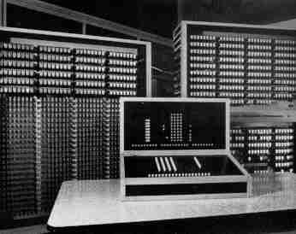
No picture of the original Z3 exists. The above picture was taken from a reconstruction made in early 1960 by Zuse KG, Bad Hersfeld. The reconstruction was made for the 1964 Interdata industry fair in Munich. In 1967, it was on display at the Montreal Expo, where it received great attention. It is now owned by the Deutsche Museum in Munich. Today, the Z3 is widely acknowledged as being the first fully functional automatic digital computer, and Konrad Zuse is acclaimed by computer scientists as being a most admired and respected computer pioneer.
Although based on relays, the Z3 was very sophisticated for its time; for example, it utilized the binary number system and could perform floating-point arithmetic.

The Z3's basic specifications were:
- a binary number system
- floating point arithmetic
- 22-bit word length, with 1 bit for the sign, 7 exponential bits and a 14-bit mantissa.
- 2,400 relays, 600 in the calculating and program section and 1,800 in the memory.
After initially setting up Zuse KG, Zuse continued his work alone and set about to develop a language for expressing computations. This work was the continuation of work he had begun in 1943 as his PhD dissertation proposal. The language that resulted he named, Plankalkül which is German for “program calculus”. Zuse described his language in a paper which he wrote in 1945, but was not published until 1972. In this paper, along with the definition of Plankalkül, were many different algorithms written in the language that covered a wide range of applications. Among these were algorithms to sort arrays of numbers; test the connectivity of a graph, calculate the square root of a number, and to perform syntax analysis on logic formulas that contained parentheses and operators in six different levels of precedence. The paper included more than 60 pages of algorithms for playing chess. Although the language was quite remarkable for its sophistication, it was never implemented on any computer, including those built by Zuse, for by the time the rest of the world knew of the language it was obsolete.

Zuse’s language exhibited many features that did not find their way into main-stream programming languages until many years after Zuse had first developed them in his unpublished paper. One of the most advanced areas of Zuse’s language was in the area of data structures which included arrays and records, some 30 years before they were introduced elsewhere.

The reason for the late publication was the effort Zuse needed for the Zuse KG from 1949-1964. The Plankalkül was a remarkably complete programming language for computers. Zuse used an unusual writing of the statements in his Plankalkül. Each data item was denoted with V (variable), C (constant), Z (intermediate result), or R (result), an integer number to mark them, and a powerful notation was used to denote the data structure of the variable. The highlights of the Plankalkül are:
- Introduction of the assignment operation, for example: V1 + V2 => R1. The sign => was introduced by Rutishauser on the ALGOL 60 GAMM-committee, but the committee did not accept it.
- Statements like V1 = V2 => R1. It means: Compare the variables V1 and V2: If they are identical then assign the value true to R1, otherwise assign the value false. Such operations could be applied on complicated data structures, too.
- Programming plans, calling sub-programs and different stop criteria.
- Conditional statements, but no ELSE statement.
- Repetition of statements (loops).
- Operations of predicate logic and the Boolean algebra.
- Powerful operations on lists and pairs of lists.
- No recursion.
- Data types like: floating point, fixed point, complex.
- Arrays, records, hierarchical data structures, list of pairs.
- Arithmetic exception handling.
- Applications to play chess are described on more than 60 pages.
- Assertion like in EIFFEL and MODULA-2.
- Complicated expressions with parentheses and nesting.

An example of an assignment statement involving arrays in Plankalkül is shown below:

pseudocode: A[7] = 5 * B[6]

Plankalkül:
| 5 * B ⇒ A
V | 6 7 (subscripts)
S | 1.n 1.2 (data types)

1949: Pseudocodes

The computers that were available during the late 1940s and early 1950s were much different beasts than are available today. For the most part they were very slow and unreliable with very small memories. Additionally, the machines were very difficult to program because there was no software support. There weren’t any operating systems, high-level languages, or even assembly languages which meant that the programmer developed code in machine language. Programming in machine code is an extremely time-consuming task with a high degree error probability. From a readability point of view, how does the program below read to you?

110101 10011 1101001001110011
101100 00110 1110110100111010
111001 01111 1011110111011011

While this type of code is hard to read, it has even bigger drawbacks in the area of modifiability. Very few programmers get it right the first time, modification of source code is the norm not the exception and machine code uses absolute addressing. In other words a program using absolute addressing is designed to load into a particular address in memory and all memory references within the program are based upon that absolute address. Therefore if a jump instruction returns control to address xxx, then the instruction to resume control had better be at address xxx. However, if you’ve inserted a new “statement” in the code above address xxx, then the correct instruction is no longer at this address. This will require searching the code and modifying all address references below the newly inserted instruction. The same will be true for the deletion of instructions. However, the “no-op” instruction was developed as a place-holder for deleted instructions so that only insertions caused a problem.

These sorts of problems associated with machine languages were the motivating factors behind the development of assembly languages.

1949: Short Code

The problems surrounding the use of machine code as the primary language in which to program computers became immediately apparent to those who worked in the field. Almost immediately, work began to develop languages in which program could be written that were more symbolic than that of machine code. One of the first of these was named Short Code by its developer John Mauchly, who developed the languages for the BINAC computer in 1949. Short Code later became the primary programming language of the UNIVAC I computer. Short Code was never officially published as a language, so a complete description of its features is not available. What is known of Short Code comes from a UNIVAC I programming manual from 1952, although it is believed that this is very similar to the original language.

The UNIVAC I was a 72-bit word machine in which the word was divided into six groups of 12 bits/byte. Short Code consisted mainly of mathematical expressions represented as codes of byte-pair values which allowed most equations to fit into a single word. Some of the Short Code codes are shown below:

01 − 06 absolute value 1n (n+2)nd power
02 ) 07 + 2n (n+2)nd root
03 = 08 pause 4n if <= n
04 / 09 ( 58 print and tab

Variables and constants were also named with byte-pair codes. For example, if X0 and Y0 are variables, the statement X0 = SQRT(ABS(Y0)) would be coded in a word as 00 X0 03 20 06 Y0. Where the most significant byte-pair code in this example (00) is simply padding.

Short Code was not translated into machine code but rather interpreted. At the time, this was called automatic programming. While it simplified the coding process compared to machine code, it was much slower, with Short Code interpretation about 50 times slower than machine code.

1951 – 1953: The UNIVAC Compiling System

Between 1951 and 1953, Grace Hopper led a UNIVAC development team which built a series of “compiling” systems named A-0, A-1, and A-2 that expanded pseudocode into machine code similar to the way a macro is expanded in an assembly language (replaced with in-line code). Although the pseudocode used by these machines was quite primitive, it nevertheless demonstrated that the future of programming was in higher-level languages. Other researchers were accomplishing the same results during this time period as well.

1954: Speedcoding

During the early 1950s much effort went into developing interpretive systems which extended machine language to include floating-point operations as the desire for more complex numerical operations grew. In 1954, John Backus developed a system called Speedcoding for the IBM 701 machine. Basically, Speedcoding converted the 701 machine into a virtual three-address floating-point calculator. Among the features of Speedcoding were:

- Four instructions for operating on floating-point numbers.
- Operations such as square root, sine, arc tangent, exponent, and logarithm.
- Auto-increment registers for array access. (This feature did not appear in hardware until 1962 on the UNIVAC 1107 computer.)
- Conditional and unconditional branch instructions.
- I/O conversions.

While, certainly a breakthrough in language design, the hardware of the IBM 701 severely limited the usefulness of Speedcoding. After loading the interpreter into the memory, the remaining usable memory decreased to only 700 words. Furthermore, it was SLOW, with an addition instruction requiring 4.2 milliseconds to execute. However, complex operations, such as matrix multiplication could be accomplished using only 12 Speedcoding instructions. The features of Speedcoding allowed Backus to state that problems which could take two weeks to program in machine code could be programmed in a few hours with Speedcoding.

1954: The IBM 704 and the Evolution of FORTRAN

Prior to 1954, computing, or what passed as computing in those days, was all scientific applications as there was virtually no business computing at the time. This type of coding was quite tedious as the hardware of the day did not support floating-point operations (the bulk of scientific computing) and thus required simulation in software. It was sheer magnitude of the processing time spent in this simulation that masked the inherent deficiencies of interpreted code that was so prevalent at the time. All that would abruptly change in 1954 with the introduction of the IBM 704 that directly lead to the development of FORTRAN.
IBM was incorporated in 1911, starting as a major producer of punch card tabulating machines. In the 1930s, IBM built a series of calculators (the 600s) based on their card processing equipment. In 1944, IBM co-sponsored the Mark 1 computer (together with Harvard University), the first machine to compute long calculations automatically.

The year 1953 saw the development of IBM's 701 EDPM, which, according to IBM, was the first commercially successful general-purpose computer. The 701's invention was part of the Korean War effort. Thomas Johnson Watson, Jr. wanted to contribute a "defense calculator" to aid in the United Nations' policing of Korea. One obstacle he had to overcome was in convincing his father, Thomas Johnson Watson, Sr. (then Chief Executive Officer of IBM) that computers would not harm IBM's card processing business. The 701s were incompatible with IBM's punched card processing equipment, a moneymaker for IBM.
Only nineteen 701s were manufactured (the machine could be rented for $15,000 per month). The first 701 went to IBM's world headquarters in New York. Three went to atomic research laboratories. Eight went to aircraft companies. Three went to other research facilities. Two went to government agencies, including the first use of a computer by the U.S. Department of Defense. Two went to the navy and the last machine went to the U.S. Weather Bureau in early 1955.
The 701 had electrostatic storage vacuum tube memory, used magnetic tape to store information, and had binary, fixed-point, single address hardware. The speed of the 701 computers was limited by the speed of its memory; the processing units in the machines were about 10 times faster than the core memory.
In 1956, a significant upgrade to the 701 appeared. The IBM 704 was considered the world's first super-computer and the first machine to incorporate floating-point hardware. The 704 used magnetic core memory that was faster and more reliable than the magnetic drum storage found in the 701. Also part of the 700 series, the IBM 7090 was the first commercial transistorized computer. Built in 1960, the 7090 computer was the fastest computer in the world. IBM dominated the mainframe and minicomputer market for the next two decades with its 700 series.
After releasing the 700 series, IBM built the 650 EDPM, a computer compatible with its earlier 600 calculator series. The 650 used the same card processing peripherals as the earlier calculators, starting the trend for loyal customers to upgrade. The 650s were IBM's first mass-produced computers (universities were offered a 60% discount).

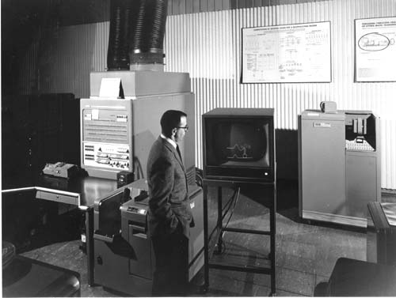
The IBM 704 Computer (1956). The first mass-produced computer with floating-point arithmetic, whose designers included John Backus, formerly of IBM Watson Laboratory at Columbia University, who also was the principal designer of FORTRAN, the first high-level language for computer programming. The 704's 6-bit BCD character set and 36-bit word account for FORTRAN's 6-character limit on identifiers.

Table 1 shows the development of the IBM 700/7000 series of computers.

Model  # | First Delivery | CPU | Memory | Cycle  Time  (μs) | Memory  Size  (k) | #  of  opcodes | # of index registers | I/O  overlap (channels) | Instruction  Fetch  Overlap | Speed  (relative  to 701)
701 | 19952 | V | tubes | 30 | 2-4 | 24 | 0 | no | no | 1X
704 | 1955 | V | core | 12 | 4-32 | 80 | 3 | no | no | 2.5X
709 | 1958 | V | core | 12 | 32 | 140 | 3 | yes | no | 4X
7090 | 1960 | T | core | 2.18 | 32 | 169 | 3 | yes | no | 25X
7094 I | 1962 | T | core | 2 | 32 | 185 | 7 | yes | yes | 30X
7094  II | 1964 | T | core | 1.4 | 32 | 185 | 7 | yes | yes | 50X
V = vacuum tube, T = transistor
Table 1 – Summary of the Evolution of the IBM 700/7000 Series Computers

John Backus and his group at IBM where the developers of the original FORTRAN (The IBM Mathematical FORmula TRANslation System) in 1954. So revolutionary was the language compared to its predecessors that Backus’ original paper declared that “FORTRAN would eliminate coding errors and the debugging process.” Based upon this bold statement the original FORTRAN compiler contained very little syntax checking.

FORTRAN was developed in an environment in which:
- Computers were relatively small (in terms of memory), slow, and unreliable.
- The primary use for computers was scientific computations.
- There did not exist any efficient ways to program computers.
- Computers cost more than programmers, the speed of generating the code was the primary goal of the first FORTRAN compilers.

FORTRAN, as many languages which ultimately followed it, was re-designed even before it was implemented. (Your textbook refers to the un-implemented version as FORTRAN 0 and the first implemented version as FORTRAN 1, however, in reality it was simply called FORTRAN as no one had the foresight to start numbering the languages.)

The first compiler for FORTRAN was released by IBM in April 1957 after 18 worker-years of effort (the programmer’s manual for the language was released in October 1956 however!).

Some of the features of FORTRAN were:
- Included logical if statements
- Post-tested counting loop
- Formatted I/O
- Six-character names (see photo above)
- User-defined subprograms
- No data-typing statements, i,…, n variables were assumed integer, all others were assumed floating-point.

Unfortunately, the 704 was not a very reliable machine and programs larger than about 400 lines of code seldom compiled correctly. But this did not slow the rapid expansion of FORTRAN programming. By April 1958 (one year after its release) approximately one-half of all code written for the 704 was in FORTRAN.

Over the years FORTRAN has undergone many revisions and upgrades. FORTRAN IV which evolved during 1960-1962, becoming the NASI standard in 1966 and remained so until 1978, when FORTRAN 77 was released. FORTRAN IV included explicit type declarations, logical selection statements, and subprograms could be passed as parameters. FORTRAN 77 added string handling capabilities and the now common if-then-else statement.

FORTRAN 90/95 is the current version of FORTRAN with FORTRAN 95 being the current standard, but differing only slightly from FORTRAN 90. FORTRAN 90/95 differs drastically from FORTRAN 77 in that it added modularity features, built-in library functions, dynamic arrays, pointers, recursion, parameter type checking, and many other features common to modern programming languages.

Look at the FORTRAN 90 example on page 49 in your text and see how you would rate the readability of FORTRAN 90.

The next version of FORTRAN, which is tentatively named FORTRAN 2000, is due to be adopted by ISO in March 2004.

Functional Programming Languages: LISP

Artificial Intelligence (AI) began to appear as an application area within computing as early as the mid-1950s. AI has its foundations in linguistics, psychology, and mathematics. The linguists were concerned with natural language processing, psychologists with modeling human thought processes and the mathematicians were concerned with mechanizing intelligent processes (such as theorem proving). Such processing is not numeric in nature but rather symbolic, so languages like FORTRAN are not particularly suited to AI work. IBM became interested in AI in the mid-1950s as well and selected theorem proving as the demonstration arena. The high cost of the FORTRAN compiler convinced IBM that a list processing language should be attached to FORTRAN rather than some additional (read: additional costly) language. From this the language FLPL, FORTRAN List Processing Language, was born.

In 1958, John McCarthy of MIT spent a summer as a researcher at the IBM Information Research Department. His goal for the summer was to investigate symbolic computations and develop a set of requirements for doing symbolic computation. McCarthy chose the differentiation of algebraic expressions as a pilot example area in which to focus. His research indicated that the control flow methods for mathematical functions of recursion and conditional expressions were necessary and FORTRAN had neither of these. Another requirement that McCarthy felt was fundamental to such computation was the need for dynamically allocated linked lists with some sort of implicit de-allocation. McCarthy felt that explicit de-allocation by the programmer would cause unnecessary clutter in programs, thus the implicit requirement. When McCarthy returned to MIT that fall, along with Marvin Minsky, he formed the MIT AI Project. Their first important project was to develop a list-processing system that was to be used initially to implement a program proposed by McCarthy called the Advice Taker. It was from this application that the first list-processing language was developed, sometimes referred to as pure LISP. The first version of LISP is often called pure LISP because it is a purely functional language.

LISP stands for LISt Processing language. In its pure form, LISP has only two types of data structures, atoms and lists. There is no need for variables or assignment. Control is handled via recursion and conditional expressions. Atoms are either symbols (identifiers) or numeric literals. The syntax of LISP is based upon lambda-calculus.

(one two three four) //a list of four atoms

one two three four

(one (two three (four))) //a list of two elements; an atom “one” and
//a list (two three (four)) which consist of
//three elements, 2 atoms “two” and “three”
//and a list (four).

one

two three

four

In a functional language, all computation is accomplished by applying functions to arguments. Neither variables nor assignment statements which are so prevalent in imperative languages are necessary in a functional language. Since iterative processes can be described recursively, no loop control statements are necessary in a functional language. These factors all add up to make pure Lisp syntactically a very simple language, yet capable of extremely complex operations. Program code and data have exactly the same format. The list (one two three four) interpreted as data is a list of four elements, when interpreted as code, it is the application of a function named one to the three parameters two, three, and four.

We will see a lot more of LISP a bit later in the term when you have the experience of programming in LISP. LISP completely dominated AI research for many years as it was the only functional language suited to such computation. In the years since LISP was developed, alternative languages, such as Prolog have become popular with some AI researchers and LISP is no longer the exclusive AI language. For the most part, pure LISP has been replaced by COMMON LISP and some of its contemporary dialects such as Scheme and ML.

The Trend Toward Sophisticated Languages: ALGOL 60

ALGOL 60 came about as the result of efforts to develop a universal programming language. By the late 1950s, virtually every research group, both industrial and academic, had developed their own “high-level” programming language. IBM had FORTRAN, Perlis at Carnegie-Tech had developed a language called IT, UNIVAC computers had two languages known as MATH-MATIC and UNICODE (both developed by Perlis), and so on. Furthermore, high-level languages were being developed within architectural frameworks, which limited their scope, often to a single machine. Code portability was non-existent. This proliferation of programming languages alarmed a number of people and various computer user groups such as SHARE (IBM’s scientific user group) and USE (UNIVAC’s Scientific Exchange) submitted a petition to the ACM (Association for Computing Machinery) on May 10,1957, to form a committee to study and recommend action to create a universal programming language. Although FORTRAN might have been considered, at the time to be a likely candidate for this universal language, it was solely owned by IBM, who would not consider releasing it for such use.

Paralleling this movement was a similar movement in Europe, which had actually begun earlier in 1955, in which GAMM (the German acronym for the Society of Applied Mathematics and Mechanics) had begun to study the design of a universal, machine-independent, algorithmic language for use on all computer hardware. The concern in Europe initially, was to prevent their domination by IBM. However, by late 1957, the proliferation of languages in the US convinced the GAMM subcommittee to widen their efforts to include the US and an invitation was sent to the ACM and in April 1958 the two groups agreed to join forces to develop a universal algorithmic language.

In a four day meeting in Zurich in the spring of 1958 a new language, initially known as IAL (International Algorithmic Language) was developed which was designed to satisfy the following criteria:

- The syntax of the language should be as close as possible to standard mathematical notation, and programs written in it should be readable with little further explanation.

- It should be possible to use the language for the description of computing processes in publications. This meant that it was easy to typeset.

- Programs in the new language must be mechanically translatable into machine language.

Depending on your point of view, the Zurich meeting either produced monumental results or never-ending arguments. In reality, it accomplished a little of both. For example, a great debate raged at the conference as to whether the decimal point should be represented as a comma (the European technique) or as a period (the US technique).

The features of the language that ultimately came to be known as ALGOL 58, was in many ways a descendant of FORTRAN, yet exhibited many unique features such as:

- Concept of a data type was formalized.
- Names could be of any length.
- Arrays could have any number of subscripts (any dimension).
- Parameters were separated by mode (in & out).
- Subscripts were placed in brackets.
- Compound statement was developed (begin…end).
- A semicolon was adopted as a statement separator.
- Assignment operator was set as :=. Recall that Zuse’s language had used ⇒ as the assignment operator, conference wanted to adopt =: as the assignment operator, but the US members of the committee wanted to use := as the assignment operator. This was another heated argument, which the US eventually won.
- If statement had an else-if clause.

The original intent of the ACM/GAMM conference had been to develop a working document that would initiate international debate on the development of a universal programming language. The committee had no intentions of proposing to implement the language, however, particularly in the US, the document was viewed more as a collection of ideas that programming languages should incorporate than as a universal standard language. As a result, three separate implementations of languages stemming from the committee’s report were developed. The language MAD was developed at University of Michigan, the U.S. Naval Electronics Group produced a language called NELIAC, and Jules Schwartz of the System Development Corporation produced JOVIAL (Jule’s Own Version of the International Algorithmic Language). JOVIAL actually became quite well-known and adopted as for 25 years it was the “official” scientific language of the U.S. Air Force! However, ultimate doom was on the horizon for ALGOL 58 when IBM decided that so much effort had gone into FORTRAN, which should not be repeated, that it formally retained FORTRAN as the scientific language for the IBM 700 series machines, thereby abandoning ALGOL 58.

In January 1960, a second ALGOL meeting was convened in Paris, which although it lasted only six days, was to shape the future of programming languages, especially imperative languages, until the present day. During the previous year (1959) ALGOL 58 had been feverishly debated in both Europe and the US and a large number of suggested improvements and modifications had been proposed. The purpose of the 1960 meeting was to act on more than 80 formal proposed changes to the ALGOL 58 language. Additionally, in 1959, Backus had introduced his new notation for describing the syntax of programming languages (later to become the well-known Backus-Naur form or BNF grammars). Peter Naur, who was the publisher of the ALGOL Bulletin, modified Backus’ form somewhat and presented a complete description of ALGOL 58 using this new syntax at the Paris meeting. Many new features were added to ALGOL as a result of this meeting, among these were:

- Block structured design of the language (affecting local scope).
- Two parameter passing methods established (pass by value and pass by name).
- Subprogram recursion was clearly defined.
- Stack-dynamic arrays were defined.
- The language still had no I/O (rejected as too machine dependent) and no string handling.

The changes to the ALGOL language that resulted from the 1960 meeting resulted in a change of name to ALGOL 60. This language was successful from a number of different points of view:
- The defacto standard for publishing algorithms for over 20 years.
- Every subsequent imperative language (PL/1, Simula67, ALGOL 68, C, Pascal, Ada, C++, Java, etc.) are in one way or another based on ALGOL 60.
- First machine-independent language.
- First language whose syntax was formally defined (using BNF).
- Initiated the fields of formal language study, parsing theory, and compiler design.
- Was the first language to influence hardware design. Burroughs B5000, B6000, and B7000 machines were designed with a hardware stack to efficiently implement the block structure and recursive procedures of the language.

However, from a different perspective, ALGOL 60 was in many ways a failure. It was never widely adopted in the US and was not adopted as widely in Europe as was initially anticipated. There are a number of reasons for the failure of ALGOL to become the universal programming language and among these are:

- Lack of I/O statements made porting the code to other machines quite difficult.
- In many ways, ALGOL was too flexible, which made understanding programs written in it difficult to understand and even more difficult to implement the language.
- While today we view BNF grammars as a concise method for defining the syntax of a programming language, it was quite new in 1960 and in its own way contributed to the demise of ALGOL.
- Perhaps more than any other factor, the entrenchment of FORTRAN and the lack of support from IBM, spelled the end for ALGOL.

